Embedded Systems  
Sample Paper

**Q1.** A Car Navigation System contains the following systems :   
->GPS Receiver (Signal Strength)

->Map Database (Stored Maps)

->Display Screen (Screen Size)

a) Identify and describe the key components in the given BDD of the car navigation system.

b) Explain the relationship between the Car Navigation System and its components.

c) Illustrate how the attributes of each component contribute to the overall functionality of the car navigation system.

d) Create a BDD visual representation based on the provided textual description of the Car Navigation System.

**Q2.** Model a Petri Net for an elevator.  
There is a building with three floors and an escalator. Each floor has a detector. On the second floor, there are two buttons, one to go up and another to go down.

The order of priority must be respected at all times. The buttons inside the elevator need to be taken into account.

**Q3.** Derive the Reachability Graphs for the given Petri Net.

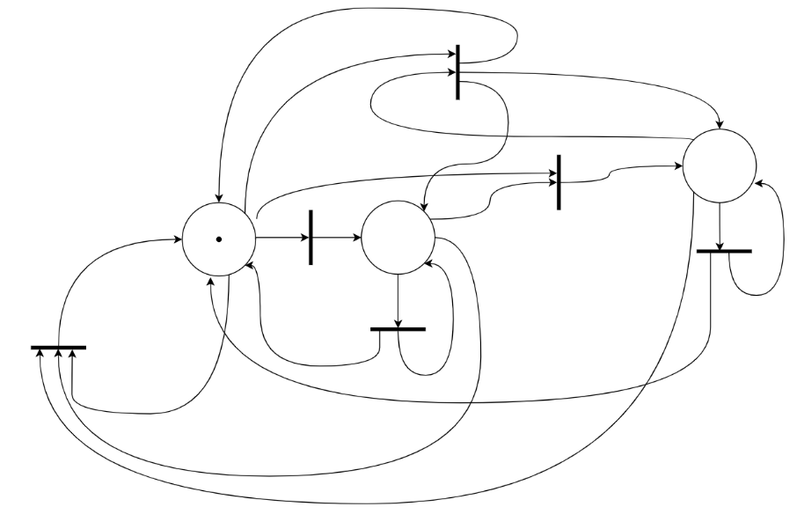

**Q4.** State whether the following Petri Nets are Alive or Quasi-Alive.

1. 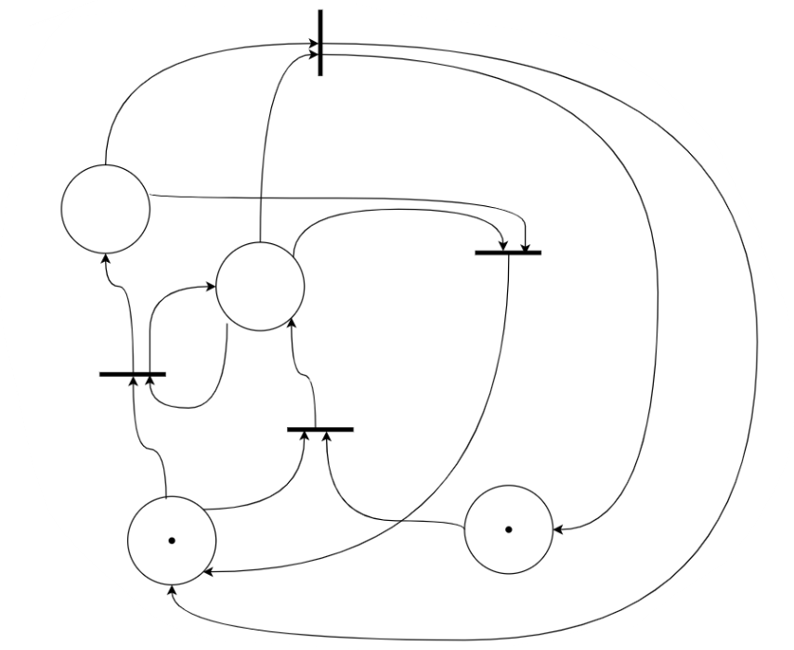
2. 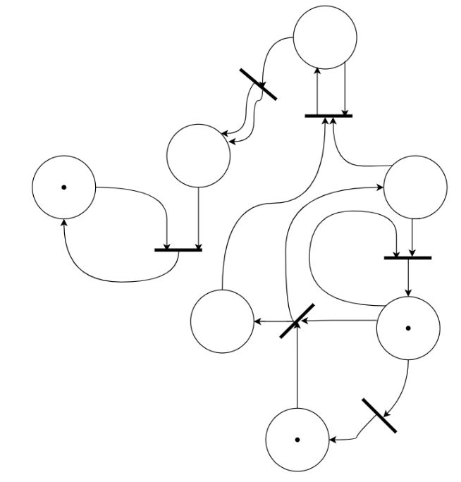

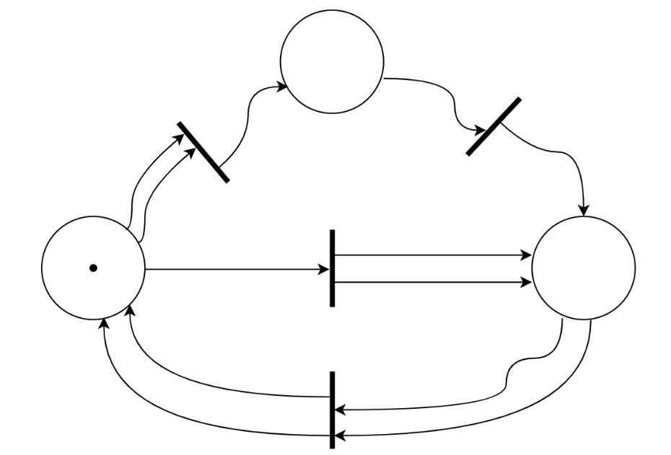

1. 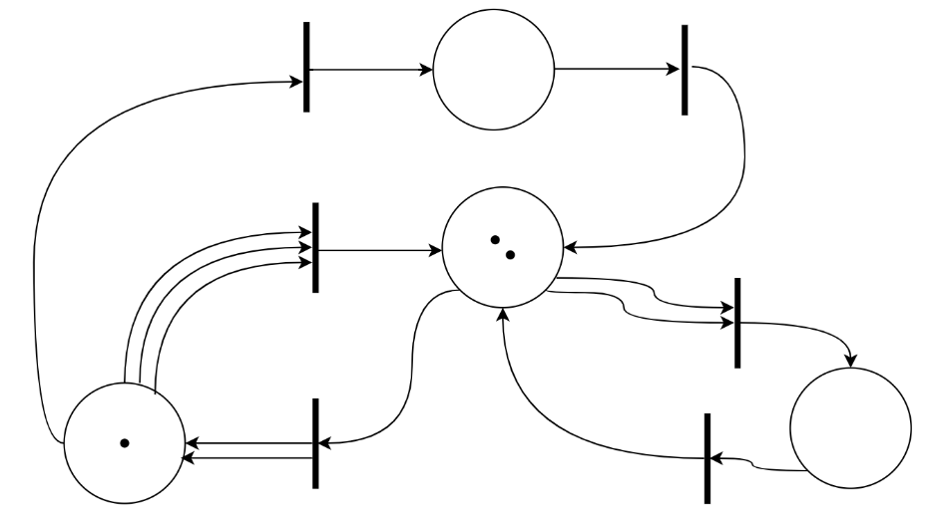
2. 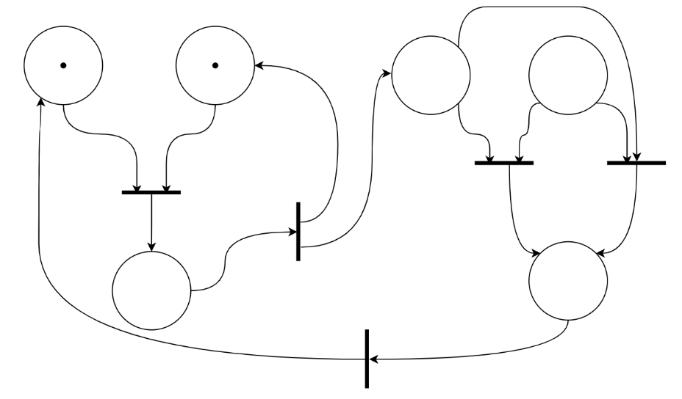
3. 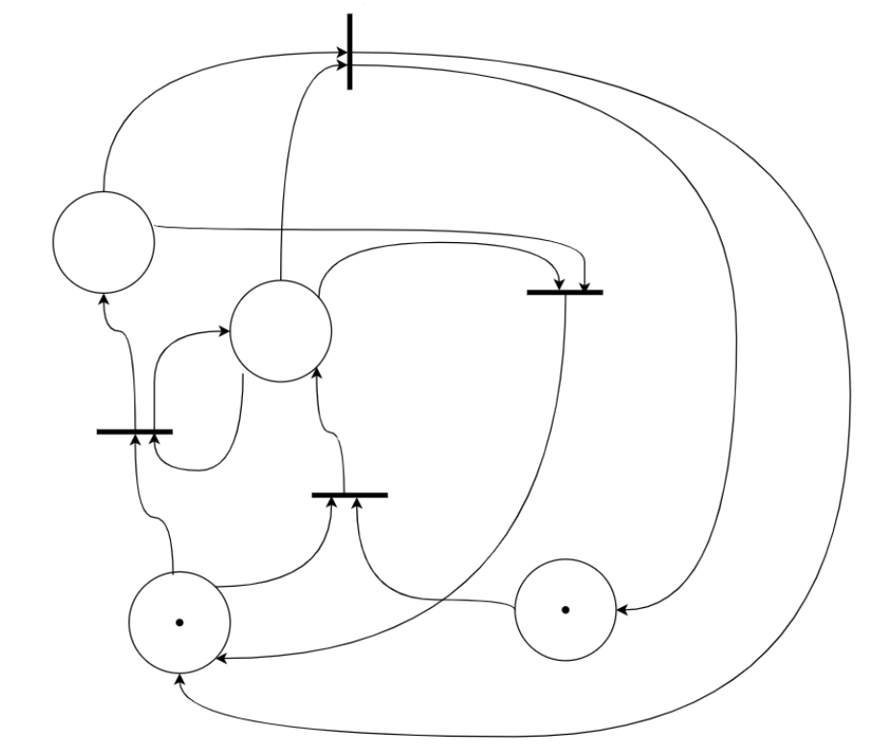

**Q5.**

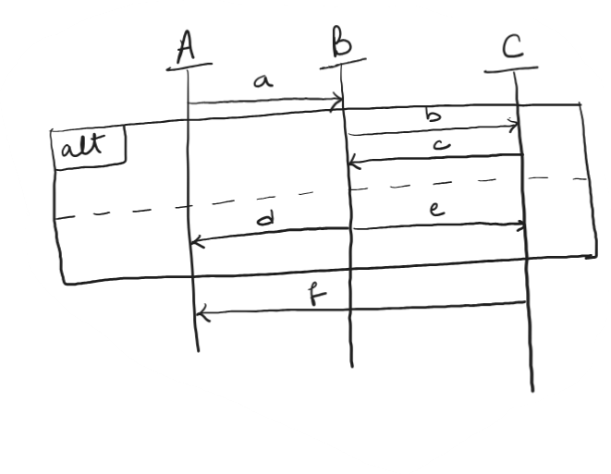

1. Define all execution paths for visual ordering.
2. Define all execution paths for causal ordering.
3. Transform into: i) Interface Automata

ii) Finite State Machine

iii) Internal Block Diagrams

**Q6.**

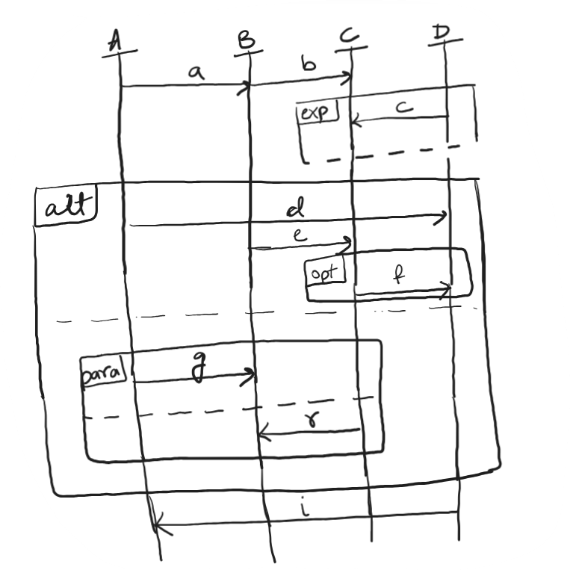

1. Define all possible execution paths.
2. Transform into: i) Interface Automata

ii) Internal Block Diagrams

**Q7.**

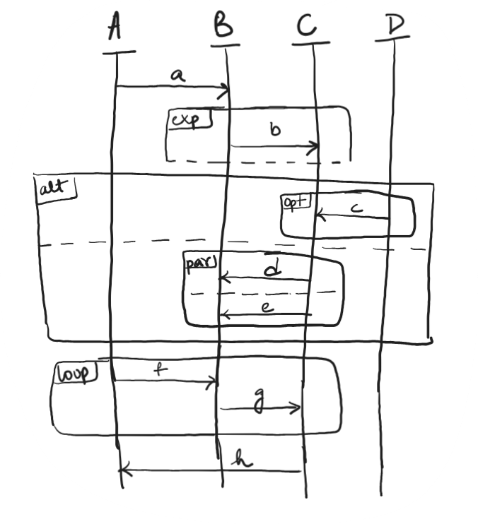

1. Define all possible execution sequences.
2. Transform into : i) Interface Automata

ii) Finite State Machine

iii) Internal Block Diagrams

**Q8.** What are the distinguishable features between petri-nets, interface automata and sequence diagram.

**Q9.** What are the three main compositions of a pet

**Q10.** What is a Reachability graph.

**Q11.** Are petri-nets deterministic? Give reasons.

**Q12.** Fill in the blanks :

1. A petri-net is potentially ______, when there is at least one marking reachable, which enables t.
2. A petri-net is ________, if no transition is able to fire in a given marking.
3. A petri-net is _______, if not dead under any future marking.
4. A petri-net is _______, when all transitions are potentially fireable for all future markings.

**Q13.** Describe the behaviour of an inhibitor.

**Q14.** What are the advantages of interface automata?

**Q15.** In a sequence diagram, you have blocks labelled as:

Alt |Exp |Opt | Par

What are the interpretations of these labels attached to the block?

**Q16.** Distinguish between visual ordering and causal ordering of a sequence diagram.

**Q17.** What modelling languages do you know?

**Q18.** Identify Safety Hazards for the following :

1. A Cobot
2. A Self Driving Car

**Q19.** What are the constraints for the following models:

1. Petri-Net
2. Interface Automata
3. Sequence Diagram

**Q20.** Explain aggregation and generalization in modelling.

**Q21.** A fires before B in a Sequence Diagram. How is this depicted?

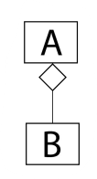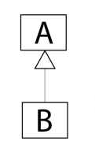**Q22.**

What is the difference between the two figures above?

**Q23.** Draw the Interface Automata for a Package Delivery Robot and make sure there is an event in case there is some lacking information:

1. Robot receives delivery instructions.

2. Navigates to the distribution centre.

3. Picks up the package.

4. Navigates to the delivery destination.

5. Drops the package

Convert the interface automata to IBD and sequence diagram

**Q24.** From the following image compose the interface automata for all three systems together:-

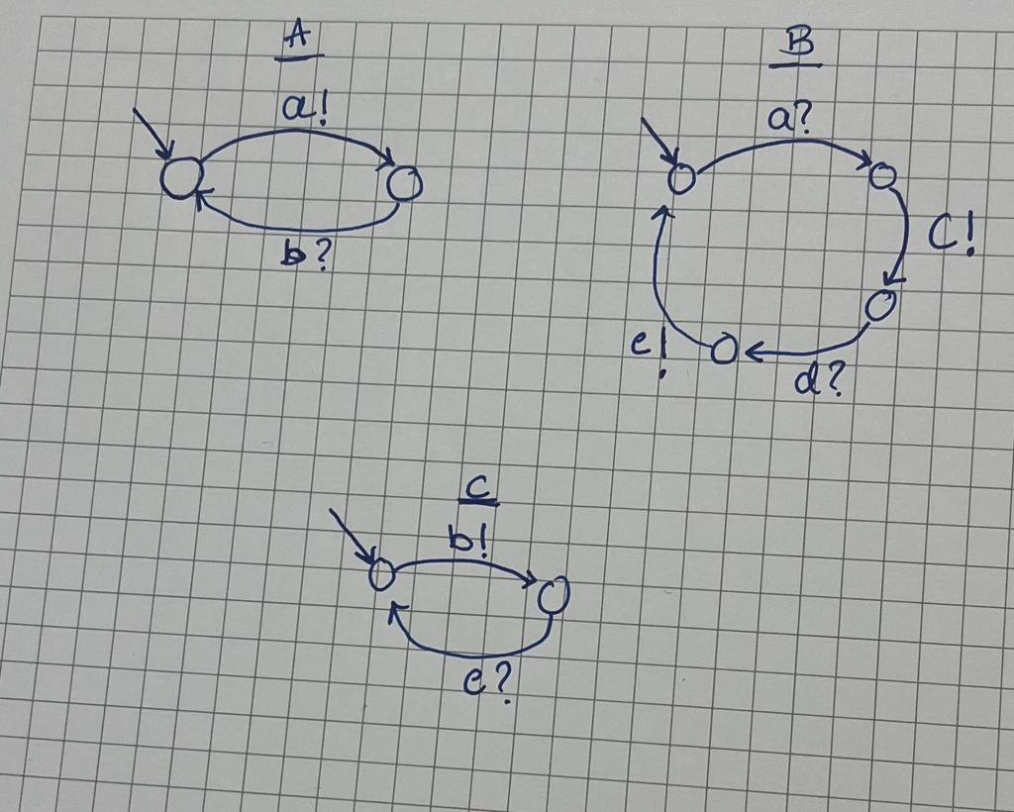

**Q25.** From the following image check if the compositions are possible or not :

1.AxB 2.BxC 3.AxC

